The Kbee
An internal EGIA Knowledge Base reference tool providing categorized articles, FAQs and internal company information.

Introducing the EGIA Kbee quick reference Knowledge Base.
- The EGIA Kbee is designed to answer questions, house common process knowledge, provide access to training information and to provide company and inter-departmental references and job-related resources.
- The EGIA Kbee will typically be the default landing page when opening a Microsoft Edge or Google Chrome Browser. Otherwise, you can access the EGIA Kbee through the following URL:
egia.thekbee.com
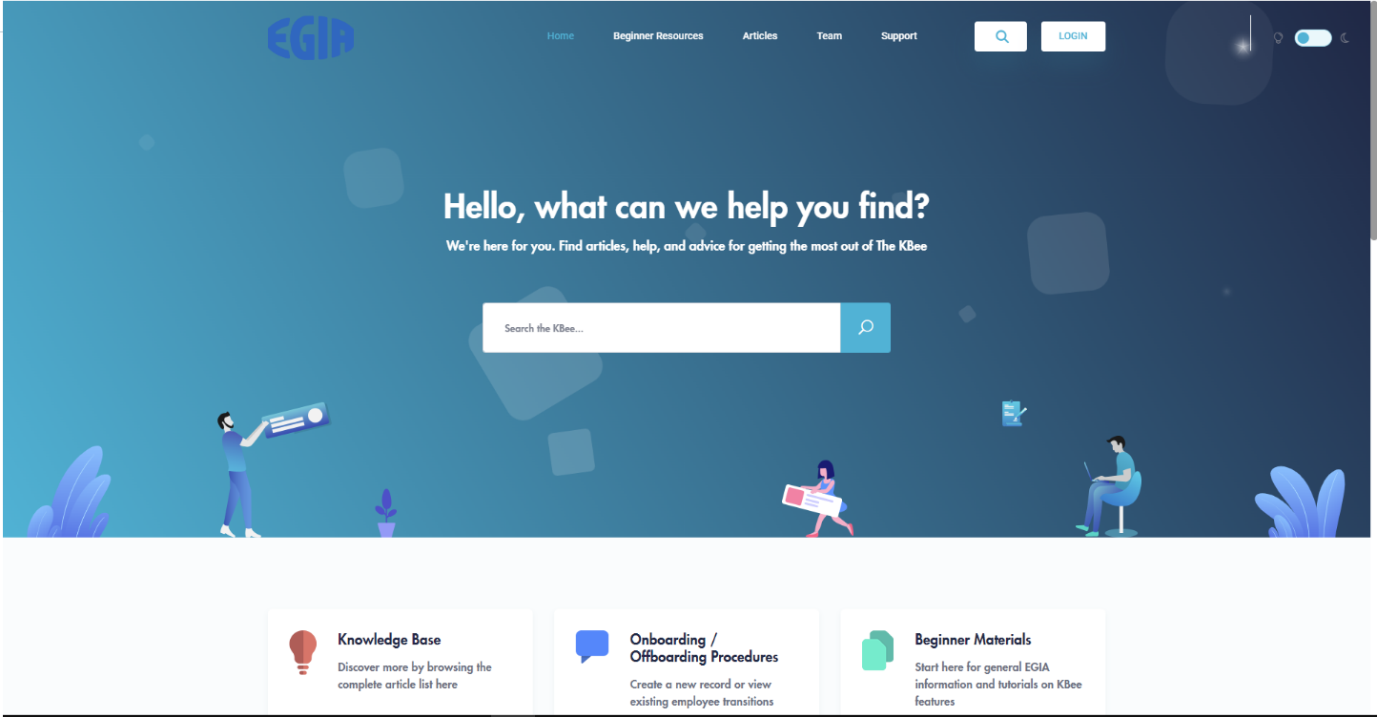

Note:
This Knowledge Base is for internal employee use only. Not to be given access to outside parties without prior approval or upper management knowledge of specific information and items being shared.

Accessing the Kbee
- Click the ‘LOGIN’ button in the upper right corner:

- Login credentials for Kbee access consist of your EGIA email address and a predefined password.

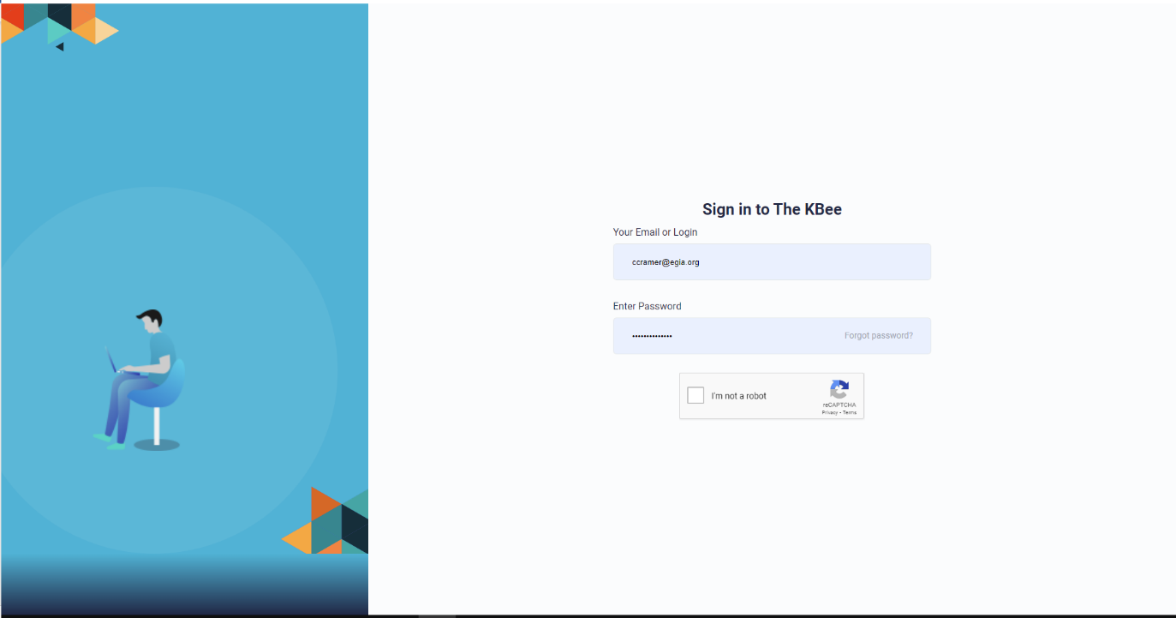

Note:

If you have yet to establish your password, simply choose the ‘Forgot password’ link. The Kbee will send out an email with instructions to get you started.

- For security purposes, we have enabled multi-factor authentication where you will select ‘you are not a robot’ or another visual, followed by a button to send a code to your email (precautions to help keep EGIA safe).

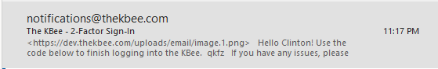

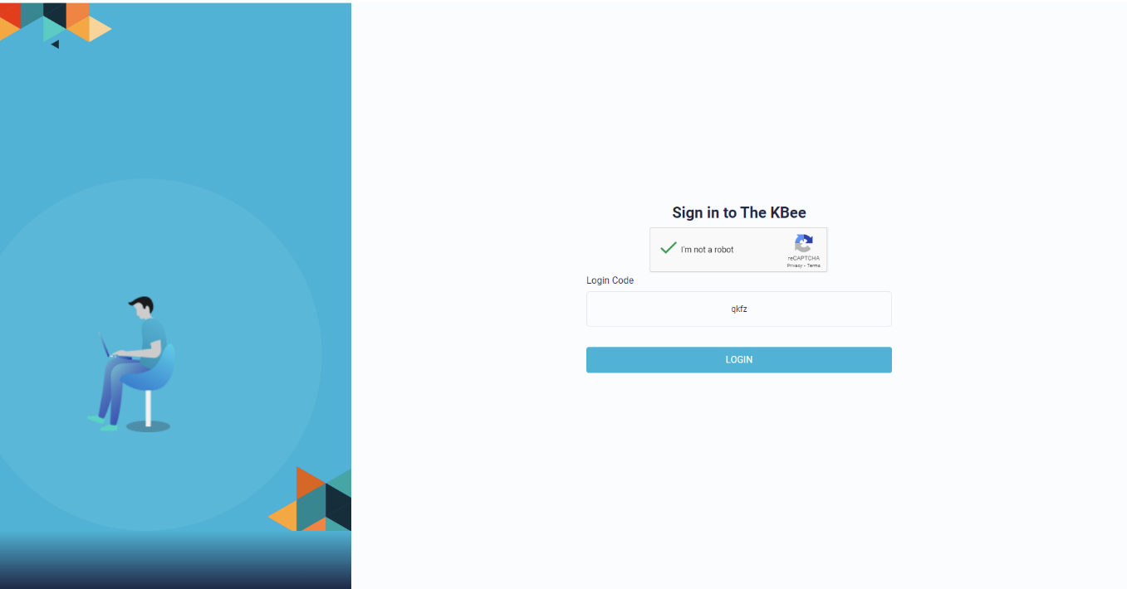

Landing pages

- Landing pages are based on EGIA departmental access.

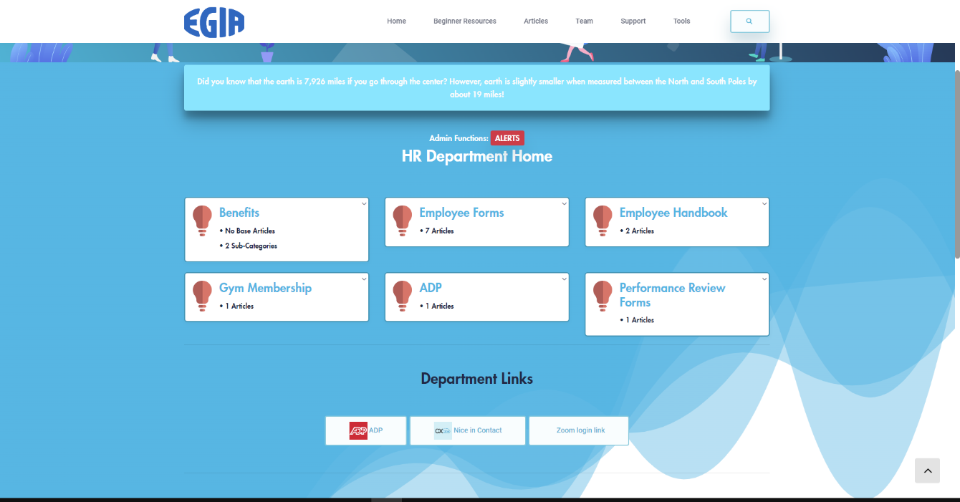

- Each page holds related information based on documents added by your departmental area management, HR, or subject matter related to that process, subject, etc. In the upper right, look for a drop down labeled ‘Your Departments:’ for an additional list of choices based on permissions:



The Kbee also includes:
- A company directory and photo galleries of past employee events located under the ‘Team’ menu at the top of the page.
- Support portals located under the ‘Support’ menu at the top of the page.

- An HR landing page.
- An Events landing page.
- Beginner resources to help with getting to know, retrieve information and navigate the Kbee site.
- Employee Onboarding tools for hiring processes and equipment acquisition.
- And eventually so much more…

Utilize the search for FAQs and How-to questions

- There will be categories or articles and documents you do not have permission to see. There will be a message to see your administrator. Permissions are set and agreed upon by IT in collaboration with the department’s management and HR.



- Look around and check it out.

- Be aware that it is under construction. Let us know if you encounter issues, find incorrect information, or have any input.

- Please see your departmental management if you would like to add information or have questions regarding area landing page info, etc.

- Feedback is encouraged. We would like to hear from you regarding how it helped, if you encountered challenges and the types of info you look for or found.

EGIA IT

